Project Report
On

EXPERT GUIDE
CHOOSE YOUR CAREER

Summer Internship Project Report
Submitted To
DataRitz Technologies
Duration 6 weeks

Session 2019-20

Submitted By
Team-App Demons
1.Umang Agrawal (Lead) 2018BCS1041
2.Shruti Gupta 2018BCS1056
3.Muskan Gupta 2018BCS1175
4.Shivank Sharma 2018BCS1009

Under the guidance of
DR. B.P. Sharma

ABES ENGINEERING COLLEGE, GHAZIABAD
 |  | 
AFFILIATED TO
DR. A.P.J. ABDUL KALAM TECHNICAL UNIVERSITY, U.P., LUCKNOW
(Formerly UPTU)

CERTIFICATE
This is to certify that Project Report entitled ’ EXPERT GUIDE ’ which is submitted by Team App Demons in partial fulfillment of the requirement for the summer internship of degree B. Tech. in Department of Computer Science and Engineering of ABES Engineering College,AKTU is a record of the candidates own work carried out by them under my supervision. The matter embodied in this thesis is original and has not been submitted for the award of any other degree.
SUPERVISOR-
DATE- 3 July 2020

ACKNOWLEDGEMENT
It gives us a great sense of pleasure to present the report of the B. Tech summer internship Project undertaken during B. Tech. Second Year. We owe special debt of gratitude to Professor B.P. Sharma, DataRitz Technologies for his constant support and guidance throughout the course of our work. His sincerity, thoroughness and perseverance has been a constant source of inspiration for us. It is only his cognizant efforts that our endeavors have seen light of the day.
We also take the opportunity to acknowledge the contribution of Head, Department of DataRitz Technologies for his full support and assistance during the development of the project. We also do not like to miss the opportunity to acknowledge the contribution of all faculty members of the DataRitz Technologies for their kind assistance and cooperation during the development of our project. Last but not the least, we acknowledge our friends for their contribution in the completion of the project.

Name- Team App Demons
Date- 3 july 2020

TABLE OF CONTENTS Page

CERTIFICATE…………………………………………………………………………….2
ACKNOWLEDGEMEMT…………………………………………………………………3

CHAPTER 1
  - Problem Introduction
1.1.1 Project Objective 5
1.1.2 Scope of the Project 6
1.1.3 Introduction to Technologies/Language 6
    - Library / In-built function / package / module 6
    - Hardware Requirement 7
    - Software Requirement 7
    - IDE 7
CHAPTER 2
2.1 Work Flow Diagrams and Prototype
2.1.1 Use Case Diagram 8
2.1.2 Data Flow Diagram(Level 0) 9
2.1.3 Data Flow Diagram(Level 1) 10
2.1.4 E/R Diagram 10
2.1.5 Front Page demo 11
2.1.6 Prototyping (Student) 12
2.1.7 Form Input For Students/College 13
CHAPTER 3
3.1CODE AND SNAPSHOTS
3.1.1 Welcome Page 15
3.1.2 Login/Sign-in Page For Students 17

3.1.3 Login/Sign-in Page For College 21
3.1.4 Forget Password 24
3.1.5 Sign-up For Students 27
3.1.6 Sign-up For College 30
3.1.7 Submit Page For Student 32
3.1.8 Search Page For College 36

CHAPTER 4
4.1Conclusion 41
4.2 References 41

Chapter 1
1.1 INTRODUCTION
We are making this app so that a student can easily select their college. As we know that various students evaluate their career through college and they find themselves either compromising on their dreams or being unable to decide between competing options. Instead of a clearly path, students are at best an independent who will survive and thrive only with a constantly evolving skill-set. So basically this app helps them to find right career profiles. In this app, there are two entities :- college/admin and student/user.
An admin or college sign-in to expert guide account and after signing in they filled their college details such as seats availability, fees details, cut-off percentage, infrastructure etc. There is an option for student sign-in also where they filled their details for admission such as the course which they want to do, exam name which they opted for, score as well as their rank of the exam which they appeared, and their category.
When the student filled their details, they will get the details of the colleges which they can apply for or take admission. They will get those particular colleges that are matched on their details or merit-basis of various competitive exams they have given. Finally, the content closes out that it will simply help students to choose right college.

Problem Introduction:

As we know, students after passing their intermediate, struggle for admission in various colleges. Why not to make their struggle easier. This project focuses on creating a platform which will in a way connect students to colleges just like Ola connects the driver and the traveller. That’s just an example..;)

1.1.1 Project Objective:

Here, on the app, student will need to enter all the details on a form input provided. It will include only relevant information such as Exam type, Course, Score/Rank based on which he/she will be provided a list of colleges. Student can also use filters on basis of fee structure or location around which he/she is looking for the colleges. Student based on his/her choice can also further select a college and get relevant information about it from our database collected already by the college.
College will remain connected to students through Expert’s Guide. Also, the college needs to regularly update all details regarding the admission such as Availability of seats, fee structure, cutoff rank/score and all other important information.

1.1.2 Scope of the Project:
This project will only display the information entered by the external user.
User can search for the college he wants to take admission in and the colleges can get the students to fill their vacant seats.

1.1.3Introduction to Technologies/Language:
React Native is a JavaScript framework used for developing a real, native mobile application for iOS and Android. It uses only JavaScript to build a mobile application. It is like React, which uses native component rather than using web components as building blocks.

Software Genre: JavaScript library
Developer: Facebook
1.1.4 Library / In-built function / package / modules used in your project:
We have used various dependencies and modules in our project. We used expo for creating the app pages ,We have used ‘figma’ for creating the prototypes for the app. We have used “android studio”s” virtual device to see the navigation of our app.

1.1.5 Hardware Requirement:

S.NO | SERVER NAME | OPERATING SYSTEM | CONFIGURATION
1. | N/A | Windows 10 | 8 GB RAM AND 64 BIT PROCESSOR

1.1.6 Software Requirement:

ITEM | VERSION | DESCRIPTION
Notepad++  Vs code | 7.7.1  latest | Notepad++ is an integrated development (IDE) which contains a base workspace and an extensible plug in system for customising the environment. Notepad++ is used for developing java applications.  Visual Studio Code is a free source-code editor made by Microsoft for Windows, Linux and macOS.^{[7]} Features include support for debugging, syntax highlighting, intelligent code completion, snippets, code refactoring, and embedded Git.

1.1.7 Integrated Development Tool(IDE)

Many improvements ,new plugins and features,more stable and major code completion enhancement,notepad version 7.7.1,Visual code are used for creating the project.

CHAPTER 2- SYSTEM DESIGN
2.1 Work Flow Diagram

2.1.1 Use Case Diagram

2.1.2 Data Flow Diagram(Level 0)

2.1.3 Data Flow Diagram(Level 1)

2.1.4 E/R Diagram

2.1.5 Front Page demo

2.1.6 Prototyping (Student)

2.1.7 Form Input For Students/College

CHAPTER 3 - CODE AND RESULTS
3.1 CODE AND SNAPSHOTS
3.1.1 Welcome Page

import React from 'react';
import { StyleSheet, Text, View, TextInput, TouchableOpacity,ImageBackground,Image } from 'react-native';

export default class App extends React.Component {

render(){
return (
<ImageBackground source={require('./bgg.PNG')} style={styles.container}>
<Text style={styles.logo}> EXPERT GUIDE </Text>
<Text style={styles.heading}> -CHOOSE YOUR CAREER</Text>
<Image source={require('./student.png')} style={{width: 100, height: 100}} />
<TouchableOpacity style={styles.loginBtn}>
<Text style={styles.loginText}>Student</Text>
</TouchableOpacity>
<Image source={require('./college.png')} style={{width: 100, height: 100}} />
<TouchableOpacity style={styles.loginBtn}>
<Text style={styles.loginText}>College</Text>
</TouchableOpacity>
</ImageBackground>
);
}
}

const styles = StyleSheet.create({
container: {
flex: 1,
alignItems: 'center',
justifyContent: 'center',

},
logo:{
fontWeight:"bold",
fontSize:40,
color:"#000302",
textShadowColor: '#000',
textShadowOffset: { width: 0.5, height: 0.5 },
textShadowRadius: 3,
marginBottom:20
},
heading:{
fontWeight:"bold",
fontSize:20,
color:"black",
marginTop:0,
justifyContent:'center',
textAlign:'center', textShadowColor: '#000',
textShadowOffset: { width: 0.5, height: 0.5 },
textShadowRadius: 3,
marginBottom:20
},
loginBtn:{
width:"80%",
backgroundColor:"#3cb371",
borderRadius:25,
height:50,
alignItems:"center",
justifyContent:"center",
textShadowColor: '#000',
textShadowOffset: { width: 0.5, height: 0.5 },
textShadowRadius: 2,
marginTop:20,
marginBottom:10,
},

});

Snapshot of welcome page :-
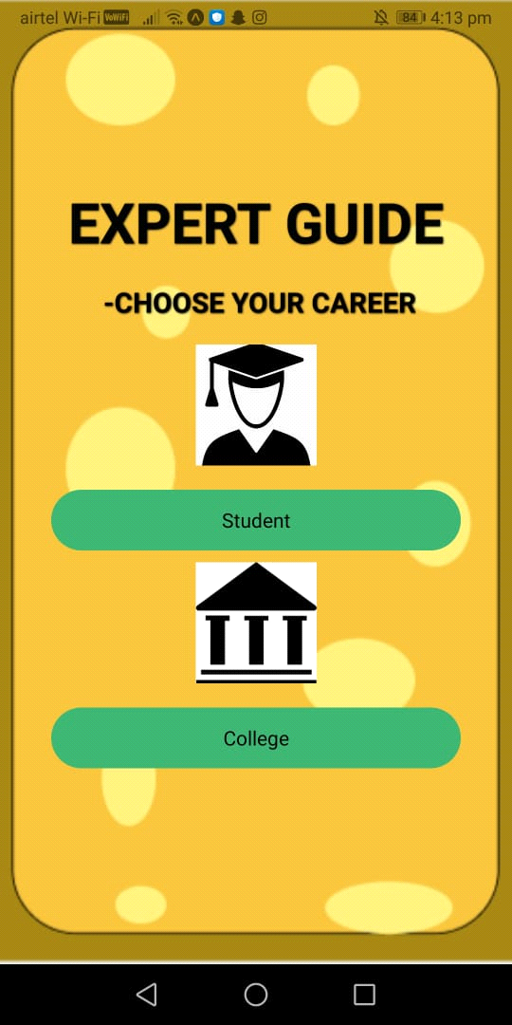

3.1.2 Login/Sign-in Page For Students
import * as React from 'react';
import { StyleSheet, Text, View, TextInput, TouchableOpacity,ImageBackground,Image } from 'react-native';
import Constants from 'expo-constants';

export default class App extends React.Component {
state={
email:"",
password:""
}

render(){
return (
<ImageBackground source={require('./aba.PNG')} style={styles.container}>
<Text style={styles.logo}> EXPERT GUIDE </Text>
<Text style={styles.logos}> -CHOOSE YOUR CAREER </Text>
<Text style={styles.logos}> FOR COLLEGE </Text>

<View style={styles.inputView} >
<TextInput
style={styles.inputText}
placeholder=" Email "
placeholderTextColor="#3cb371"
onChangeText={text => this.setState({email:text})}/>
</View>
<View style={styles.inputView} >
<TextInput
secureTextEntry
style={styles.inputText}
placeholder=" Password"
placeholderTextColor="#3cb371"
onChangeText={text => this.setState({password:text})}/>
</View>
<TouchableOpacity>
<Text style={styles.forgot}>Forgot Password?</Text>
</TouchableOpacity>

<TouchableOpacity style={styles.loginBtn}>
<Text style={styles.loginText}>LOGIN</Text>
</TouchableOpacity>
<TouchableOpacity>
<Text style={styles.loginText}>Signup</Text>
</TouchableOpacity>
</ImageBackground>

);

}
}

const styles = StyleSheet.create({
container: {
flex: 1,
backgroundColor: '#f4c13c',
alignItems: 'center',
justifyContent: 'center',
},
logo:{
fontWeight:"bold",
fontSize:40,
color:"#000302",
textShadowColor: '#000',
textShadowOffset: { width: 0.5, height: 0.5 },
textShadowRadius: 3,
marginBottom:20
},
logos:{
fontWeight:"bold",
fontSize:20,
color:"#000302",
marginBottom:40,
fontStyle:"Unica One",
textShadowColor: '#000',
textShadowOffset: { width: 0.5, height: 0.5 },
textShadowRadius: 1,
},
inputView:{
width:"80%",
backgroundColor:"#ecee99",
borderRadius:25,
height:50,
marginBottom:20,
justifyContent:"center",
textShadowColor: '#000',
textShadowOffset: { width: 0.5, height: 0.5 },
textShadowRadius: 1,
padding:20,
},

inputText:{
height:50,
color:"black",
justifyContent:"center",

},
forgot:{
color:"white",
fontSize:11
},
loginBtn:{
width:"80%",
backgroundColor:"#3cb371",
borderRadius:25,
height:50,
alignItems:"center",
justifyContent:"center",
textShadowColor: '#000',
textShadowOffset: { width: 0.5, height: 0.5 },
textShadowRadius: 1,
marginTop:40,
marginBottom:10,
},
});

Snapshot of login page of student :-
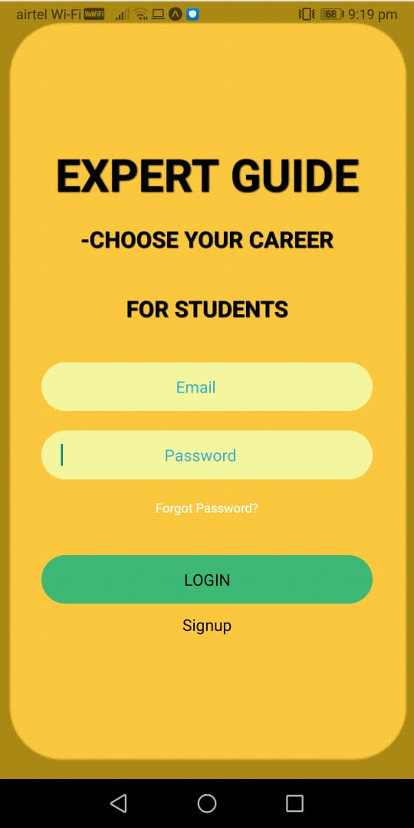

3.1.3 Login/Sign-in Page For College
import * as React from 'react';
import { StyleSheet, Text, View, TextInput, TouchableOpacity,ImageBackground,Image } from 'react-native';
import Constants from 'expo-constants';

export default class App extends React.Component {
state={
email:"",
password:""
}

render(){
return (
<ImageBackground source={require('./aba.PNG')} style={styles.container}>
<Text style={styles.logo}> EXPERT GUIDE </Text>
<Text style={styles.logos}> -CHOOSE YOUR CAREER </Text>
<Text style={styles.logos}> FOR STUDENTS </Text>

<View style={styles.inputView} >
<TextInput
style={styles.inputText}
placeholder=" Email "
placeholderTextColor="#36aac9"
onChangeText={text => this.setState({email:text})}/>
</View>
<View style={styles.inputView} >
<TextInput
secureTextEntry
style={styles.inputText}
placeholder=" Password"
placeholderTextColor="#36aac9"
onChangeText={text => this.setState({password:text})}/>
</View>
<TouchableOpacity>
<Text style={styles.forgot}>Forgot Password?</Text>
</TouchableOpacity>

<TouchableOpacity style={styles.loginBtn}>
<Text style={styles.loginText}>LOGIN</Text>
</TouchableOpacity>
<TouchableOpacity>
<Text style={styles.loginText}>Signup</Text>
</TouchableOpacity>
</ImageBackground>

);

}
}

const styles = StyleSheet.create({
container: {
flex: 1,
backgroundColor: '#f4c13c',
alignItems: 'center',
justifyContent: 'center',
},
logo:{
fontWeight:"bold",
fontSize:40,
color:"#000302",
textShadowColor: '#000',
textShadowOffset: { width: 0.5, height: 0.5 },
textShadowRadius: 3,
marginBottom:20
},
logos:{
fontWeight:"bold",
fontSize:20,
color:"#000302",
marginBottom:40,
fontStyle:"Unica One",
textShadowColor: '#000',
textShadowOffset: { width: 0.5, height: 0.5 },
textShadowRadius: 1,
},
inputView:{
width:"80%",
backgroundColor:"#ecee99",
borderRadius:25,
height:50,
marginBottom:20,
justifyContent:"center",
textShadowColor: '#000',
textShadowOffset: { width: 0.5, height: 0.5 },
textShadowRadius: 1,
padding:20,
},

inputText:{
height:50,
color:"black",
justifyContent:"center",

},
forgot:{
color:"white",
fontSize:11
},
loginBtn:{
width:"80%",
backgroundColor:"#3cb371",
borderRadius:25,
height:50,
alignItems:"center",
justifyContent:"center",
textShadowColor: '#000',
textShadowOffset: { width: 0.5, height: 0.5 },
textShadowRadius: 2,
marginTop:40,
marginBottom:10,
},
});

Snapshot of login page of college:-
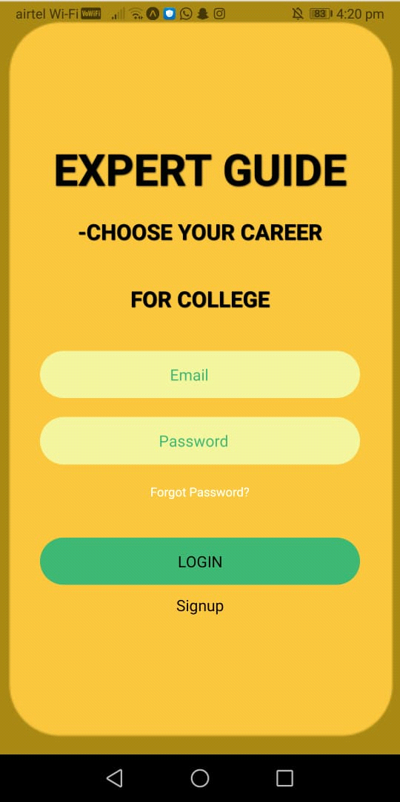

3.1.4 Forget Password

import * as React from 'react';
import { Text, View, StyleSheet,TextInput ,TouchableOpacity} from 'react-native';
import Constants from 'expo-constants';

export default function App() {
return (
<View style={styles.container}>
<Text style={styles.paragraph}>
forgot your Password?
</Text>
<Text style={styles.paragraph1}>
type your email to reset your password!
</Text>
<TextInput
style={styles.inputText}
placeholder="Enter your email"
placeholderTextColor="#3cb371"/>
<TouchableOpacity style={styles.resetBtn}>
<Text style={styles.loginText}>Reset Password</Text>
</TouchableOpacity>
<TouchableOpacity style={styles.resetBtn}>
<Text style={styles.loginText}>Back To Login</Text>
</TouchableOpacity>
</View>
);
}
const styles = StyleSheet.create({
container: {
flex: 1,
justifyContent: 'center',
paddingTop: Constants.statusBarHeight,
backgroundColor: '#f4c13c',
alignItems:'center',

},
paragraph: {
color:'#fff',
fontSize: 25,
fontWeight: 'bold',
textAlign: 'center',
},
paragraph1: {
color:'#fff',
fontSize: 15,
fontWeight: '300',
textAlign: 'center',
marginBottom:60,
},
inputText:{
padding:12,
marginBottom:10,
width:'80%',
backgroundColor:'#fff',
borderRadius:25,
height:40,
borderWidth: 1,
},
resetBtn:{

width:"40%",
backgroundColor:"#3cb371",
borderRadius:80,
height:50,
alignItems:"center",
justifyContent:"center",
marginTop:20,
marginBottom:10
},
loginText:{
color:"#fff",
}
});

Snapshot of forget password:-

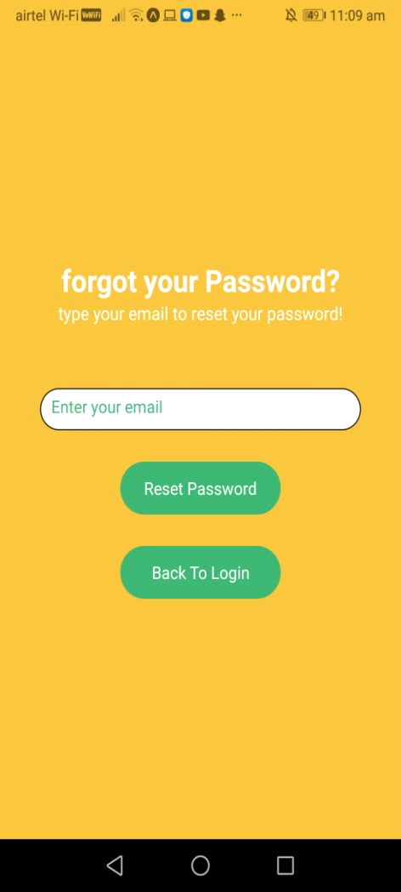

3.1.5 Sign-up For Students

import React, {useState} from 'react';
import {Picker, Text, StyleSheet, View, TextInput, Button, TouchableOpacity} from 'react-native';

const PickerDemo = () => {
return (
<View style={styles.container}>
<Text style={styles.formLabel}> Join us! </Text>
<View>
<TextInput placeholder="Name" style={styles.inputStyle} />
<TextInput placeholder="Contact" style={styles.inputStyle} />
<TextInput placeholder="City" style={styles.inputStyle} />
<TextInput placeholder="Field of Study" style={styles.inputStyle} />
<TextInput placeholder="E-mail" style={styles.inputStyle} />
<TextInput placeholder="School" style={styles.inputStyle} />
<TextInput placeholder="Something about you" style={styles.inputStyle} />
<TouchableOpacity style={styles.loginBtn}>
<Text style={styles.loginText}>Register</Text>
</TouchableOpacity>
<Text
style={{
fontSize: 35,
color: 'black',

alignItems: 'center',
justifyContent: 'center',
}}>
</Text>
{/* <Butto title="Submit color="#fff onPress={() => alert('Simple Button pressed')}/> */}
</View>
</View>
);
};

const styles = StyleSheet.create({
container: {
flex: 1,
backgroundColor: '#f4c13c',
alignItems: 'center',
justifyContent: 'center',
},
formLabel: {
fontSize: 20,
color: 'black',
fontWeight:"bold",
},
inputStyle: {
marginTop: 20,
width: 300,
height: 40,
paddingHorizontal: 10,
borderRadius: 50,
backgroundColor: '#ecee99',
},

loginBtn: {
width:"99%",
backgroundColor:"#ecee99",
borderRadius:25,
height:50,
alignItems:"center",
justifyContent:"center",
marginTop:80,
marginBottom:10
},
loginText:{
color:"black",
fontWeight:"bold", }
});

export default PickerDemo;

Snapshot of sign-up for students:-

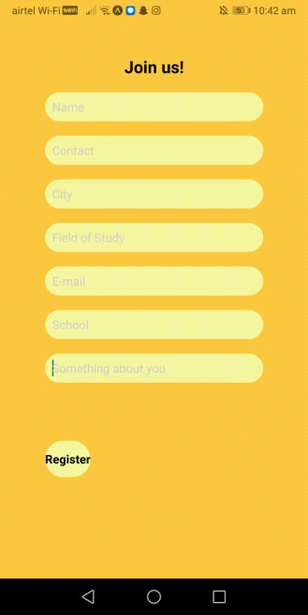

3.1.6 Sign-up For College

import React, {useState} from 'react';
import {Picker, Text, StyleSheet, View, TextInput, Button, TouchableOpacity} from 'react-native';

const PickerDemo = () => {
return (
<View style={styles.container}>
<Text style={styles.formLabel}> Join us! </Text>
<View>
<TextInput placeholder="College Name" style={styles.inputStyle} />
<TextInput placeholder="Affiliated University" style={styles.inputStyle} />
<TextInput placeholder="Private/Govt" style={styles.inputStyle} />
<TextInput placeholder="Courses Offered" style={styles.inputStyle} />
<TextInput placeholder="E-mail" style={styles.inputStyle} />
<TextInput placeholder="City Located" style={styles.inputStyle} />
<TextInput placeholder="Fee Information" style={styles.inputStyle} />
<TouchableOpacity style={styles.loginBtn}>
<Text style={styles.loginText}>Register</Text>
</TouchableOpacity>
<Text
style={{
fontSize: 35,
color: 'black',

alignItems: 'center',
justifyContent: 'center',
}}>
</Text>
{/* <Button
title="Submit"
color="#fff"
onPress={() => alert('Simple Button pressed')}
/> */}
</View>
</View>
);
};

const styles = StyleSheet.create({
container: {
flex: 1,
backgroundColor: '#f4c13c',
alignItems: 'center',
justifyContent: 'center',
},
formLabel: {
fontSize: 20,
color: 'black',
fontWeight:"bold",
},
inputStyle: {
marginTop: 20,
width: 300,
height: 40,
paddingHorizontal: 10,
borderRadius: 50,
backgroundColor: '#ecee99',
},

loginBtn: {
width:"99%",
backgroundColor:"#ecee99",
borderRadius:25,
height:50,
alignItems:"center",
justifyContent:"center",
marginTop:80,
marginBottom:10
},
loginText:{
color:"#3cb371",
fontWeight:"bold", }
});

export default PickerDemo;

Snapshot of sign-up for college:-

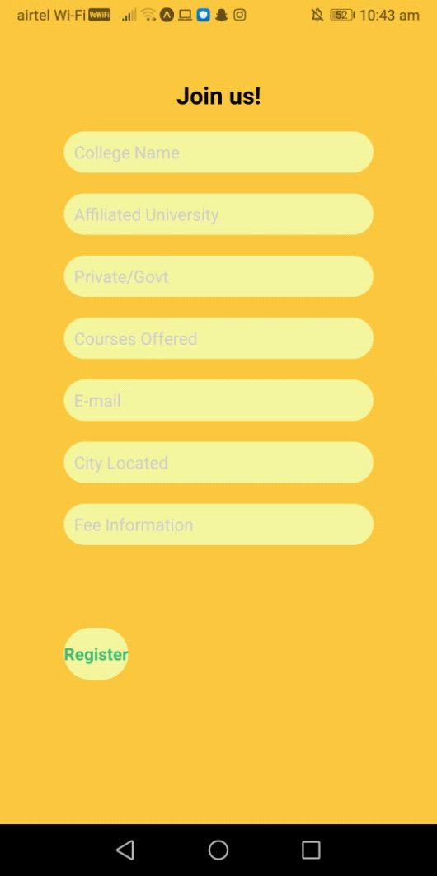

3.1.7 Submit Page For Student

import * as React from 'react';
import { Text, View, StyleSheet, TextInput, TouchableOpacity } from 'react-native';
import Constants from 'expo-constants';

export default class App extends React.Component {
state={
seats:"",
feeStructure:"",
lastdatetoregister:"",
registrationLink:""
}
render(){
return(
<View style={styles.container}>
<Text style={styles.logo}>EXPERT GUIDE</Text>
<Text style={styles.logos}>-CHOOSE YOUR CAREER</Text>
<View style={styles.inputView}>
<TextInput
style={styles.inputText}
placeholder="Seats vacant"
placeholderTextColor="#3cb371"
onChangeText={text => this.setState({ seats:text})}/>
</View>
<View style={styles.inputView}>
<TextInput
style={styles.inputText}
placeholder="Fee structure"
placeholderTextColor="#3cb371"
onChangeText={text => this.setState({feeStructure:text})}/>
</View>
<View style={styles.inputView}>
<TextInput
style={styles.inputText}
placeholder="Last date to register"
placeholderTextColor="#3cb371"
onChangeText={text => this.setState({lastdatetoregister:text})}/>
</View>
<View style={styles.inputView}>
<TextInput
style={styles.inputText}
placeholder="Registrtaion Link"
placeholderTextColor="#3cb371"
onChangeText={text => this.setState({registrationlink:text})}/>
</View>
<TouchableOpacity style={styles.SubmitBtn}>
<Text style={styles.SubmitText}>SUBMIT</Text>
</TouchableOpacity>
</View>

);
}
}

const styles = StyleSheet.create({
container: {
flex: 1,
justifyContent: 'center',
backgroundColor: '#f4c13c',
alignItems: 'center',
},
logo:{
fontWeight:"bold",
fontSize:40,
color:"#000302",
textShadowColor: '#000',
textShadowOffset: { width: 0.5, height: 0.5 },
textShadowRadius: 3,
marginBottom:20
},
logos:{
fontWeight:"bold",
fontSize:20,
color:"#000302",
marginBottom:40,
fontStyle:"Unica One",
textShadowColor: '#000',
textShadowOffset: { width: 0.5, height: 0.5 },
textShadowRadius: 1,
},
inputView: {
width: '80%',
backgroundColor:'#ecee99',
borderRadius: 25,
height: 45,
marginBottom: 20,
marginTop: 10,
justifyContent: 'center',
padding: 5,

},
inputText:{
height:50,
color: 'black',
justifyContent: 'center',
textAlign: 'center',

},
SubmitBtn: {
width: "80%",
backgroundColor: "#3cb371",
borderRadius: 25,
height: 40,
alignItems: 'center',
juystifyContent: 'center',
marginTop: 20,
marginBottom: 20,
padding:10,
textShadowColor: '#000',
textShadowOffset: { width: 0.5, height: 0.5 },
textShadowRadius: 2,
},
})

Snapshot of submit page for student:-

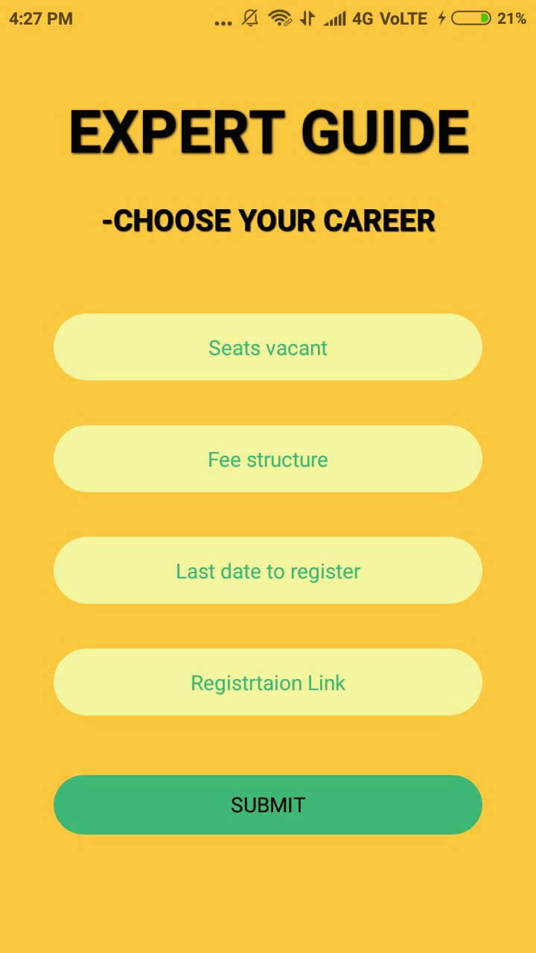

3.1.8 Search Page For College

import * as React from 'react';
import { Text, View, StyleSheet,TextInput,TouchableOpacity } from 'react-native';
import Constants from 'expo-constants';

export default function App() {
return (
<View style={styles.container}>
<Text style={styles.logo}>
EXPERT GUIDE
</Text>
<Text style={styles.logos}>
-choose your Career
</Text>
<Text style={styles.logo1}>
Course Name:
</Text>
<TextInput
style={styles.inputText}
placeholder="Enter Course Name"
placeholderTextColor="#3cb371"/>
<Text style={styles.logo2}>
Exam Name:
</Text>
<TextInput
style={styles.inputText}
placeholder="Enter Exam Name"
placeholderTextColor="#3cb371"/>
<Text style={styles.logo3}>
Score:
</Text>
<TextInput
style={styles.inputText}
placeholder="Enter Score"
placeholderTextColor="#3cb371"/>
<Text style={styles.logo4}>
Rank:
</Text>
<TextInput
style={styles.inputText}
placeholder="Enter Rank"
placeholderTextColor="#3cb371"
placeholderTextMarginLeft="10"/>
<TouchableOpacity style={styles.loginBtn}>
<Text style={styles.loginText}>SEARCH</Text>
</TouchableOpacity>
</View>
);
}

const styles = StyleSheet.create({
container: {
flex: 1,
justifyContent: 'center',
paddingTop: Constants.statusBarHeight,
backgroundColor: '#f4c13c',
alignItems:'center',

},
logo: {
marginTop: 0,
marginBottom:10,
fontSize: 35,
fontWeight: 'bold',
textAlign: 'center',
color:'black',
},
logos: {
marginLeft:40,
marginBottom:40,
fontSize: 25,
fontWeight: 'italics',
textAlign: 'center',
color:'black',
},
logo1: {

marginBottom:10,
fontSize: 20,
fontWeight: 'bold',
textAlign: 'center',
color:'black',
},
logo2: {

marginBottom:10,
fontSize: 20,
fontWeight: 'bold',
textAlign: 'center',
color:'black',
},
logo3: {

marginBottom:10,
fontSize: 20
fontWeight: 'bold',
textAlign: 'center',
color:'black',
},
logo4: {

marginBottom:10,
fontSize: 20,
fontWeight: 'bold',
textAlign: 'center',
color:'black',
},
inputText:{
padding:12,
marginBottom:10,
width:'80%',
backgroundColor:'#fff',
borderRadius:25,
height:40,
borderWidth: 1,
},
loginBtn:{
width:"40%",
backgroundColor:"#3cb371",
borderRadius:80,
height:50,
alignItems:"center",
justifyContent:"center",
marginTop:20,
marginBottom:10
}
});

Snapshot of search page for college:-

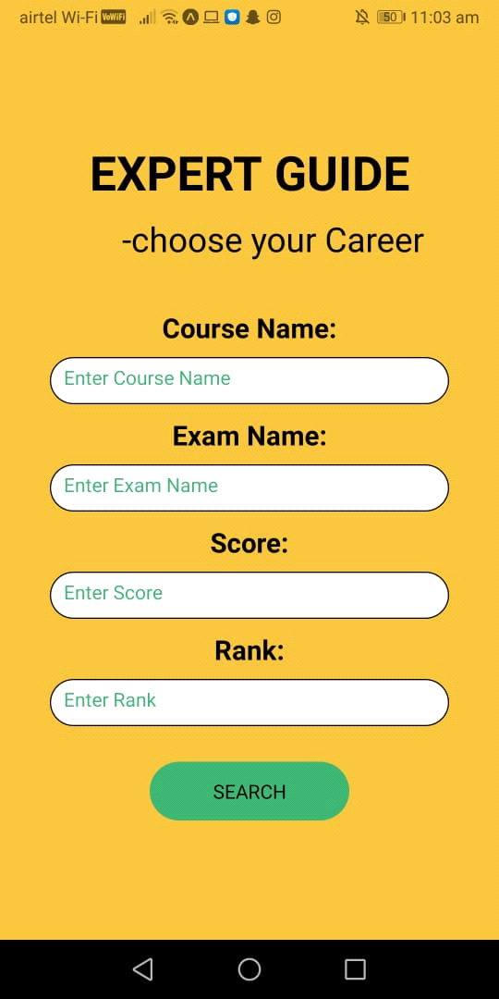

CHAPTER 4

4.1Conclusion

This app helps the students to find right career profiles by establishing their interaction with the colleges .It gives the career guidance to the students by providing them the suitable college that will ultimately lead to their bright future.

4.2References

- http://reactnavigation.org/
- https://www.w3schools.com/react/

